**Project Design Phase**

**Problem – Solution Fit Template**

|  |  |
| --- | --- |
| Date | 15 February 2025 |
| Team ID | LTVIP2025TMID48532 |
| Project Name | Measuring the Pulse of Prosperity: An Index of Economic Freedom Analysis |
| Maximum Marks | 2 Marks |

**Problem – Solution Fit Template:**

Create an **interactive Tableau dashboard** that:

* Simplifies large datasets.
* Allows users to explore and **compare economic indicators** by country and year.
* Makes it easier to draw conclusions and take action from visual insights.

**Purpose:**

The initiative is not just about building a tool—it aims to:

* **Address real user needs** by aligning with how users think, act, and process information.
* **Accelerate adoption** by using platforms and channels that people already trust.
* **Refine messaging** to clearly communicate the tool’s value and relevance.
* **Build trust** by solving recurring or costly user problems—like information overload or inaccessible analysis.
* **Empathize with users’ reality**, improving solutions by truly understanding their starting point.

**Template:** 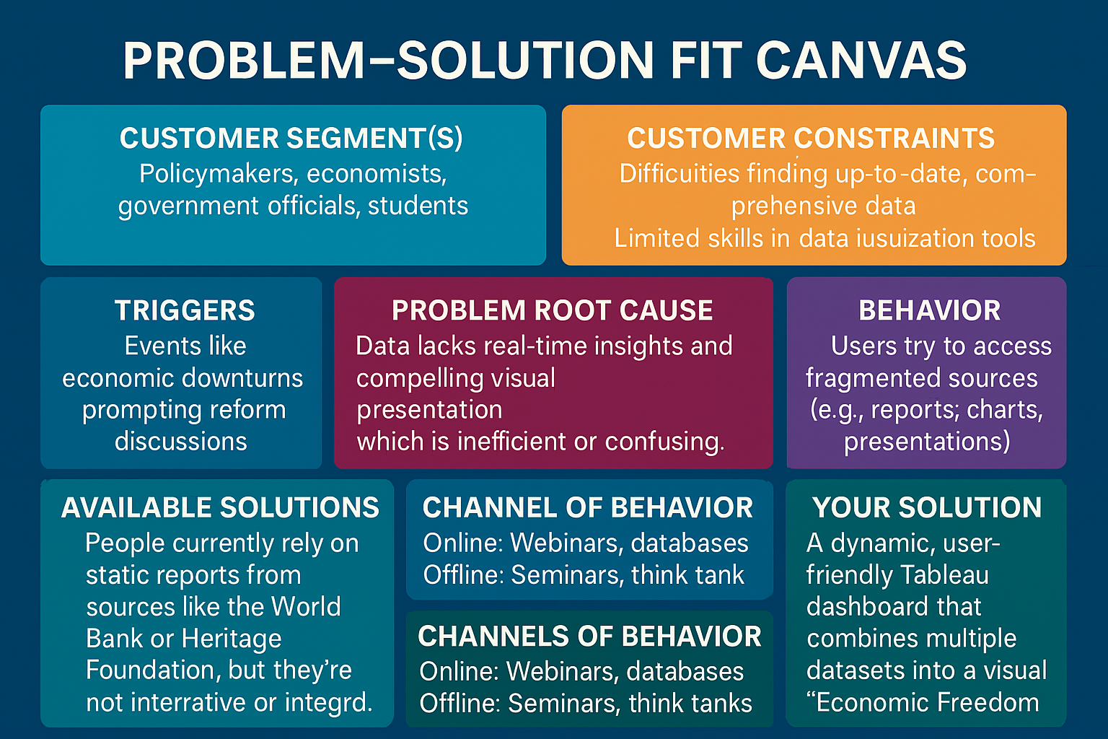

References:

1. <https://www.ideahackers.network/problem-solution-fit-canvas/>
2. <https://medium.com/@epicantus/problem-solution-fit-canvas-aa3dd59cb4fe>